Amazon Sales Dashboard – Detailed Report

**Data source:** sample-data-10mins.xlsx  
**Period:** 2022-01-03 to 2022-08-31

|  |  |  |  |
| --- | --- | --- | --- |
| Total Amount (₹) | 6,183,625 | Total Boxes Shipped | 177,007 |
| Number of Orders | 1,094 | Average Amount / Order (₹) | 5,652.31 |
| Average Boxes / Order | 161.80 | Avg Amount per Box (₹/Box) | 34.93 |
| Countries | 6 | Products | 22 |
| Latest Month Amount (₹) | 743,148 | MoM Change (₹ / %) | -60,277 ( -7.5% ) |
|  |  |  |  |

## Amount by Month

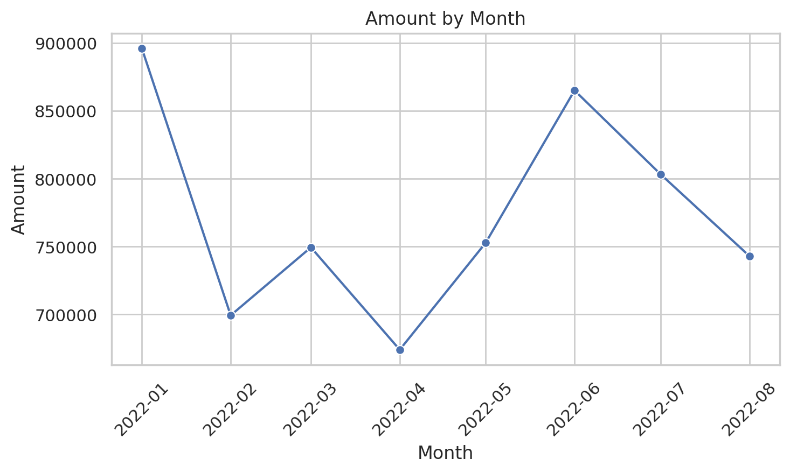

## Boxes Shipped by Country

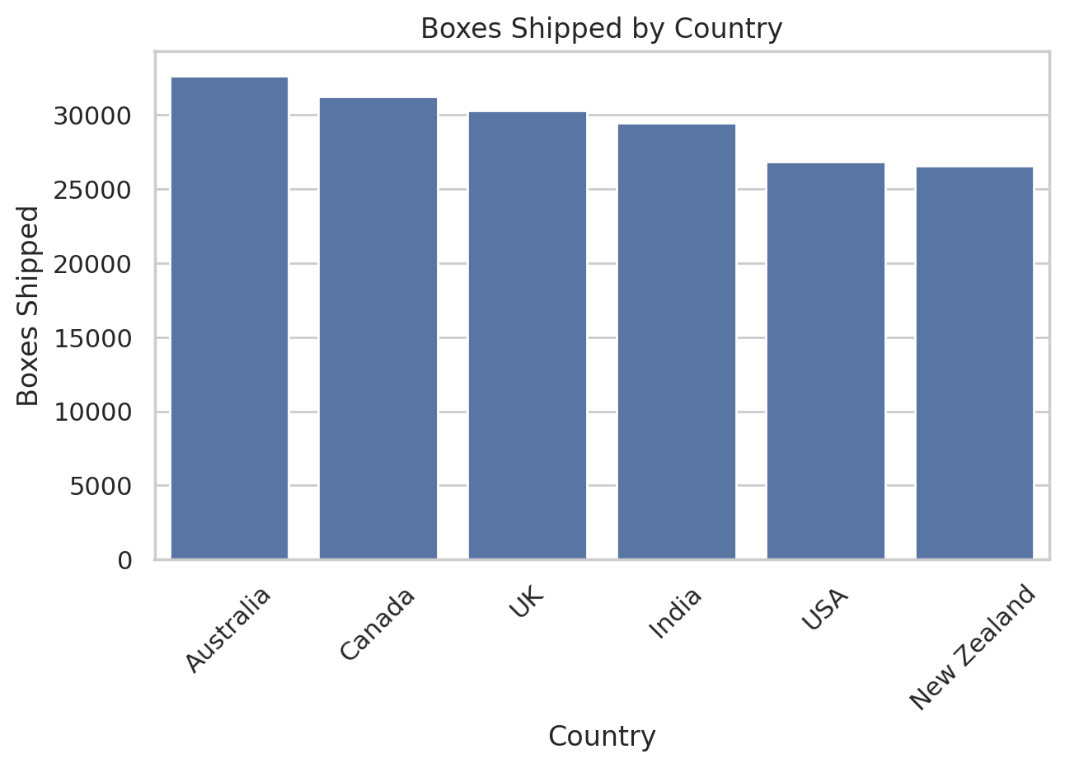

## Top 10 Products by Boxes Shipped

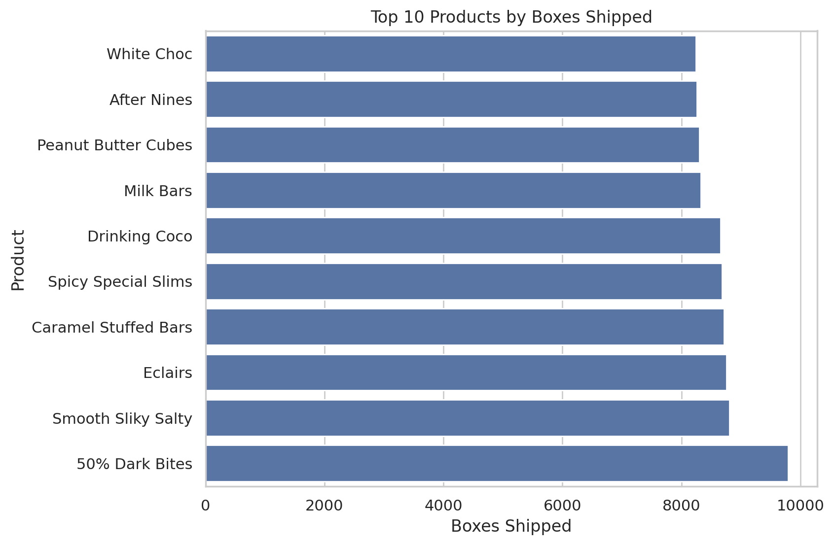

## Top 10 Products by Amount

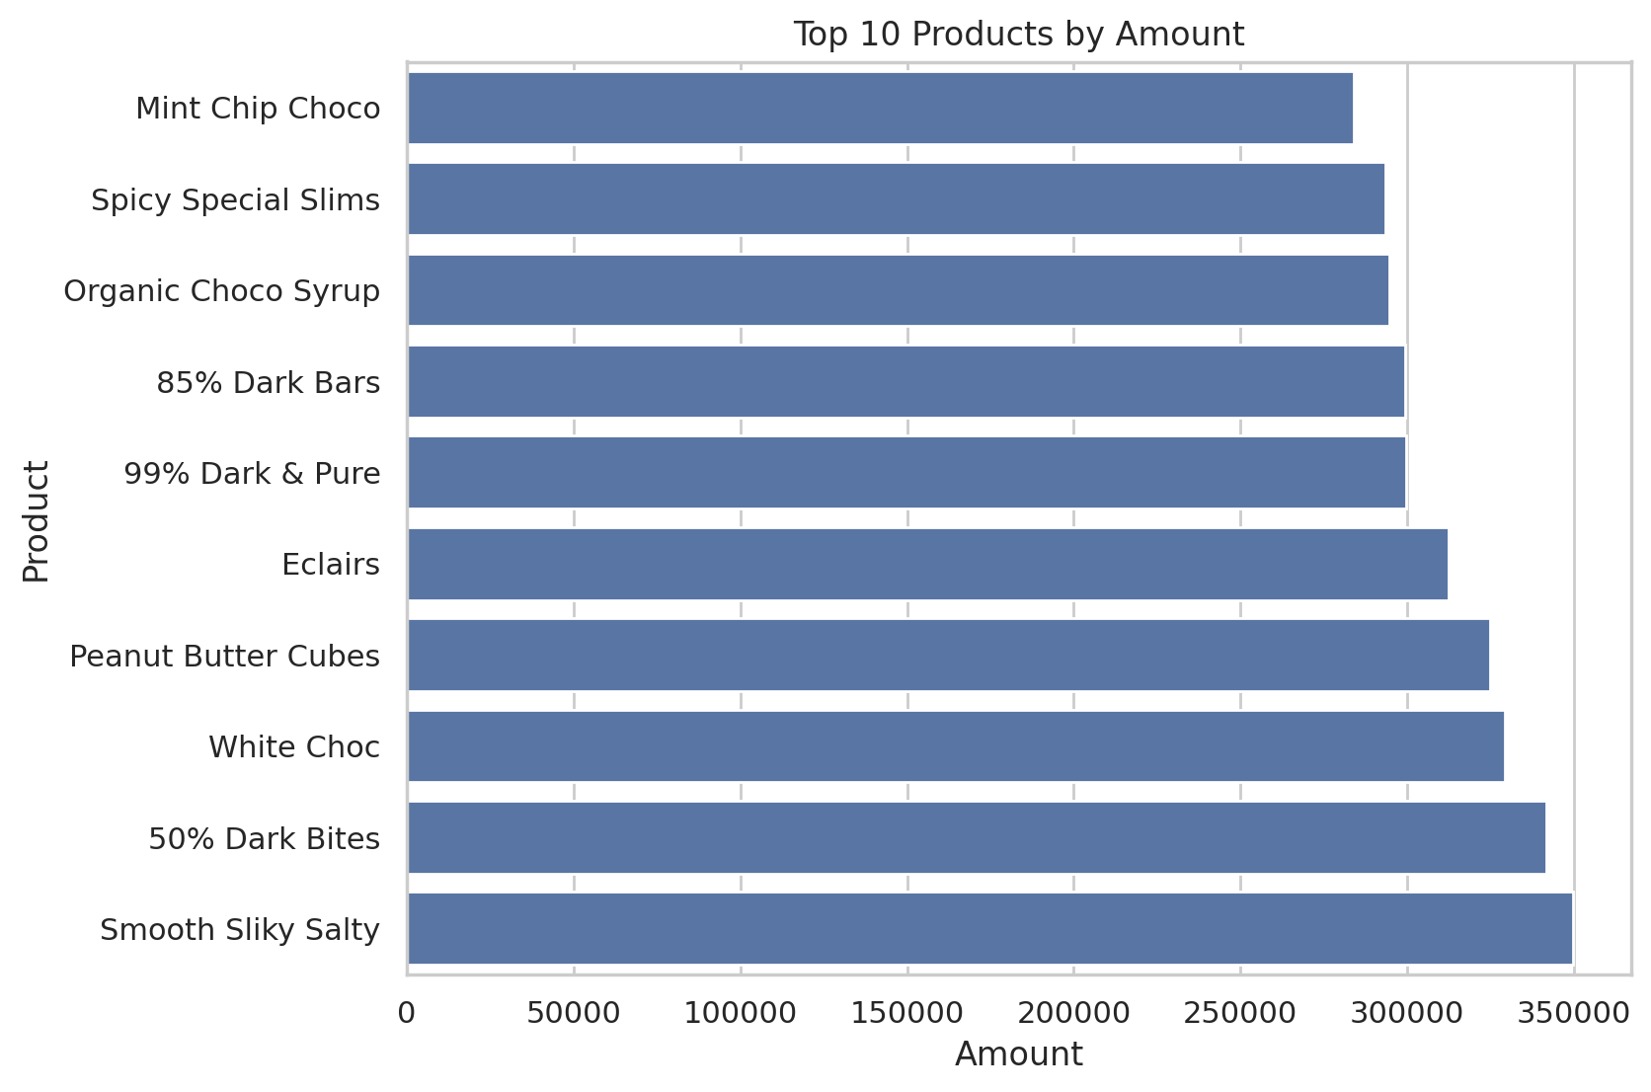

## Amount by Country (Top 15)

|  |  |
| --- | --- |
| Country | Amount |
| Australia | 1137367 |
| UK | 1051792 |
| India | 1045800 |
| USA | 1035349 |
| Canada | 962899 |
| New Zealand | 950418 |

## Amount by Sales Person (Top 15)

|  |  |
| --- | --- |
| Sales Person | Amount |
| Ches Bonnell | 320901 |
| Oby Sorrel | 316645 |
| Madelene Upcott | 316099 |
| Brien Boise | 312816 |
| Kelci Walkden | 311710 |
| Van Tuxwell | 303149 |
| Dennison Crosswaite | 291669 |
| Beverie Moffet | 278922 |
| Kaine Padly | 266490 |
| Marney O'Breen | 259742 |
| Barr Faughny | 258713 |
| Roddy Speechley | 251062 |
| Gunar Cockshoot | 238483 |
| Gigi Bohling | 232666 |
| Karlen McCaffrey | 223895 |